Scripting Languages
All scripting languages are programming languages. The scripting language is basically a language where instructions are written for a run time environment. They do not require the compilation step and are rather interpreted. It brings new functions to applications and glue complex system together. A scripting language is a programming language designed for integrating and communicating with other programming languages.
There are many scripting languages some of them are discussed below:
- bash: It is a scripting language to work in the Linux interface. It is a lot easier to use bash to create scripts than other programming languages. It describes the tools to use and code in the command line and create useful reusable scripts and conserve documentation for other people to work with.
- Node js: It is a framework to write network applications using JavaScript. Corporate users of Node.js include IBM, LinkedIn, Microsoft, Netflix, PayPal, Yahoo for real-time web applications.
- Ruby: There are a lot of reasons to learn Ruby programming language. Ruby’s flexibility has allowed developers to create innovative software. It is a scripting language which is great for web development.
- Python: It is easy, free and open source. It supports procedure-oriented programming and object-oriented programming. Python is an interpreted language with dynamic semantics and huge lines of code are scripted and is currently the most hyped language among developers.
- Perl: A scripting language with innovative features to make it different and popular. Found on all windows and Linux servers. It helps in text manipulation tasks. High traffic websites that use Perl extensively include priceline.com, IMDB.
Advantages of scripting languages:
- Easy learning: The user can learn to code in scripting languages quickly, not much knowledge of web technology is required.
- Fast editing: It is highly efficient with the limited number of data structures and variables to use.
- Interactivity: It helps in adding visualization interfaces and combinations in web pages. Modern web pages demand the use of scripting languages. To create enhanced web pages, fascinated visual description which includes background and foreground colors and so on.
- Functionality: There are different libraries which are part of different scripting languages. They help in creating new applications in web browsers and are different from normal programming languages.
Application of Scripting Languages: Scripting languages are used in many areas:
- Scripting languages are used in web applications. It is used in server side as well as client side. Server side scripting languages are: JavaScript, PHP, Perl etc. and client side scripting languages are: JavaScript, AJAX, jQuery etc.
- Scripting languages are used in system administration. For example: Shell, Perl, Python scripts etc.
- It is used in Games application and Multimedia.
- It is used to create plugins and extensions for existing applications.

Difference Between Programming, Scripting, and Markup Languages

When it comes to making a website or app coding involves basically three types of languages i.e the programming language, Scripting Language and Markup Language.
There are a lot of people who consider coding as just developing or making a website but they need to understand every single language fits into a particular category and we need to know which category that language fits into. We will discuss in detail about the difference between these three main categories or pillars of a website or an app i.e. Programming language, Scripting Language and Markup Language.

Programming language: In simple terms, programming languages are set of instructions or code which tells a computer what it needs to do. So basically, we provide a logic or instruction to the computer to perform some task to get the desired output from it. When we need to write a CD or burn a CD or when we need to paste something in pen drive these all instruction is given through some software which involves some instructions or set of code and this software communicate to the hardware. Programming languages are high-level languages that need to be converted into machine level language because a computer can only understand machine level language or binary language (0 and 1). So we write the instructions in human-readable form and then we hit the compile button to convert this into machine level language which a computer can understand and then the computer performs the task. This conversion is done by the compiler which scans the complete code in one go and if it finds any error it immediately throws all errors. Examples are Java, C, C++, C#. Programming languages are most widely used to make software or drivers.

Scripting Language: As the name suggest, it’s all about giving the script to perform some certain task. Scripting languages are basically the subcategory of programming languages which is used to give guidance to another program or we can say to control another program, so it also involves instructions. It basically connects one language to one another languages and doesn’t work standalone. Javascript, PHP, Perl, Python, VBScript these all are the examples of scripting language. Scripting languages need to be interpreted (Scanning the code line by line, not like compiler in one go) instead of compiled. There is no scope of compiler in scripting languages. Scripting languages are most widely used to create a website.

Markup Languages: Markup languages are completely different from programming languages and scripting languages. Markup languages prepare a structure for the data or prepare the look or design of a page. These are presentational languages and it doesn’t include any kind of logic or algorithm, for example, HTML. HTML is not asking any kind of question to the computer or it’s not comparing things and it’s not asking any logical question. It’s just used to represent a view inside a web browser. It tells the browser how to structure data for a specific page, layout, headings, title, table and all or styling a page in a particular way. So basically it involves formatting data or it controls the presentation of data. Examples of Markup languages are HTML, CSS or XML. These languages are most widely used to design a website.

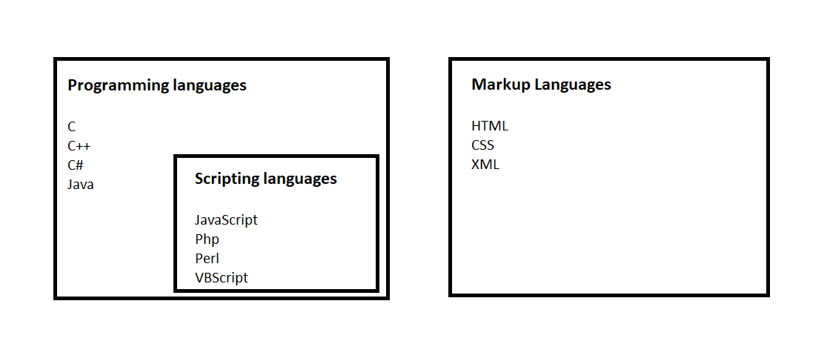
Introduction to JavaScript
JavaScript is a dynamic computer programming language. It is lightweight and most commonly used as a part of web pages, whose implementations allow client-side script to interact with the user and make dynamic pages. It is an interpreted programming language with object-oriented capabilities.
History
JavaScript was first known as LiveScript, but Netscape changed its name to JavaScript, possibly because of the excitement being generated by Java. JavaScript made its first appearance in Netscape 2.0 in 1995 with the name LiveScript. The general-purpose core of the language has been embedded in Netscape, Internet Explorer, and other web browsers.
The ECMA-262(European Computer Manufacturer's Association) Specification defined a standard version of the core JavaScript language.
This Ecma Standard defines the ECMAScript 2021 Language. It is the twelfth edition of the ECMAScript Language Specification. Since publication of the first edition in 1997, ECMAScript has grown to be one of the world's most widely used general-purpose programming languages. It is best known as the language embedded in web browsers but has also been widely adopted for server and embedded applications.

- JavaScript is a lightweight, interpreted programming language.
Interpreted Language:
An interpreted language is a programming language which are generally interpreted, without compiling a program into machine instructions. It is one where the instructions are not directly executed by the target machine, but instead read and executed by some other program. Interpreted language ranges – JavaScript, Perl, Python, BASIC, etc.
- Designed for creating network-centric applications.
- Complementary to and integrated with Java.
- Complementary to and integrated with HTML.
- Open and cross-platform
There are many useful Javascript frameworks and libraries available:
Angular
React
jQuery
Vue.js
Ext.js
Ember.js
Meteor
Mithril
Node.js
Polymer
Aurelia
Backbone.js etc.
Applications of Javascript Programming
- As mentioned before, Javascript is one of the most widely used programming languages (Front-end as well as Back-end). It has it's presence in almost every area of software development. I'm going to list few of them here:
- Client side validation - This is really important to verify any user input before submitting it to the server and Javascript plays an important role in validting those inputs at front-end itself.
- Manipulating HTML Pages - Javascript helps in manipulating HTML page on the fly. This helps in adding and deleting any HTML tag very easily using javascript and modify your HTML to change its look and feel based on different devices and requirements.
- User Notifications - You can use Javascript to raise dynamic pop-ups on the webpages to give different types of notifications to your website visitors.
- Back-end Data Loading - Javascript provides Ajax library which helps in loading back-end data while you are doing some other processing. This really gives an amazing experience to your website visitors.
- Presentations - JavaScript also provides the facility of creating presentations which gives website look and feel. JavaScript provides RevealJS and BespokeJS libraries to build a web-based slide presentations.
- Server Applications - Node JS is built on Chrome's Javascript runtime for building fast and scalable network applications. This is an event based library which helps in developing very sophisticated server applications including Web Servers.
JavaScript can "display" data in different ways:
- Writing into an HTML element, using innerHTML.
- Writing into the HTML output using document.write().
- Writing into an alert box, using window.alert().
- Writing into the browser console, using console.log()
Writing into an HTML element, using innerHTML.

<!DOCTYPE html>
<html>
<body>
<h2>My First Web Page</h2>
<p>My First Paragraph.</p>
<p id="demo"></p>
<script>
document.getElementById("demo").innerHTML = 8*5;
</script>
</body>
</html>
<!DOCTYPE html>
<html>
<body>
<h2>Welcome to Poornima University</h2>
<script>
document.write(18/6);
</script>
<script>
</body>
</html>
<!DOCTYPE html>
<html>
<body>
<h2>Display of result on button click</h2>
<button type="button" onclick="document.write(18*5)">Calculate</button>
</body>
</html>

<!DOCTYPE html>
<html>
<body>
<h2>Alert Box</h2>
<script>
window.alert(6*6);
</script>
</body>
</html>
<!DOCTYPE html>
<html>
<body>
<script>
console.log(5 + 6);
</script>
</body>
</html>

